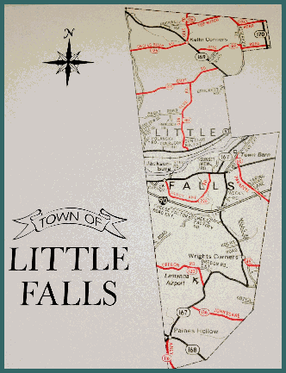
TOWN OF LITTLE FALLS
PLANNING BOARD
SITE PLAN CONFERENCE APPLICATION

Prior to undertaking any new land use, except for one or two family dwellings and other uses specifically exempted in Section 305 of the current Site Plan Law, a site plan approval by the Planning Board is required. Applicants for site plan approval must follow the procedures for the Sketch Plan Conference as hereinafter set forth. Applicants must also comply with all other procedures and requirements of this local law, as Per Section 405 of the Site Plan Law.

This application and any accompanying information required by the Town of Little Falls Site Plan Review Local Law #1 of 2015, must be submitted to the Town Clerk no later than 14 days prior to the next regular meeting of the Planning Board. Regular meetings are held on the first Tuesday of each month.

Name of Applicant: (Please Print)________________________________________________________________________
Mailing Address:(Street)______________________________________________(State) ____________ (Zip)__________

Telephone:_____________________________ Email address:______________________________________________

Owner of Record:____________________________________________________________________________________

Mailing Address:(Street)______________________________________________(State)____________ (Zip)___________

Telephone:_____________________________ Email address:______________________________________________

If applicant is not the owner, indicate applicant’s interest in the land_____________________________________________

___________________________________________________________________________________________________

Location of Property Address/Road Name:________________________________________________________________

Tax Map#__________ Block_________ Lot_______ Acreage_______

Description of Project/Activity:__________________________________________________________________________

___________________________________________________________________________________________________

Applicant Certification: The information provided in this application and the accompanying materials is true and correct to the best of my knowledge. I am aware of the penalties of obtaining Site Plan approval through deception, inaccurate or misleading information. I hereby authorize the Planning Board and its agents to inspect the subject property, at reasonable times, both before and after a final decision is made.

______________________________________ _________________________________________
Signature of Applicant Date
______________________________________ _________________________________________
Signature of Owner Date
___________________________________________________________________________________
For Official Use Only:_________________________________________________________________

Date Received: ____________ Fee Paid: ________ Received By: ______________________________________

Site Plan Review Needed: __________ Yes __________ No
* If a Site Plan Review is required, a fee of $100.00 will be levied.
Contact Information:
Chairman Bob Brown, 125 Sunset View Rd., Little Falls, NY 13365; 315-823-0035; rbrown1121@icould.com
Sandra Regan, 124 O’Hara Rd, Little Falls NY 13365, (315) 823-2879; townclerk_townoflittlefallsny@yahoo.com

Revision 01/2026

